Project : Student Application Dashboard
For this project I made a report sample of student applications, I started by creating samples of student details on a Microsoft Excel sheet consisting of applicants name, year of application, Country Applied to and Cost of Application.
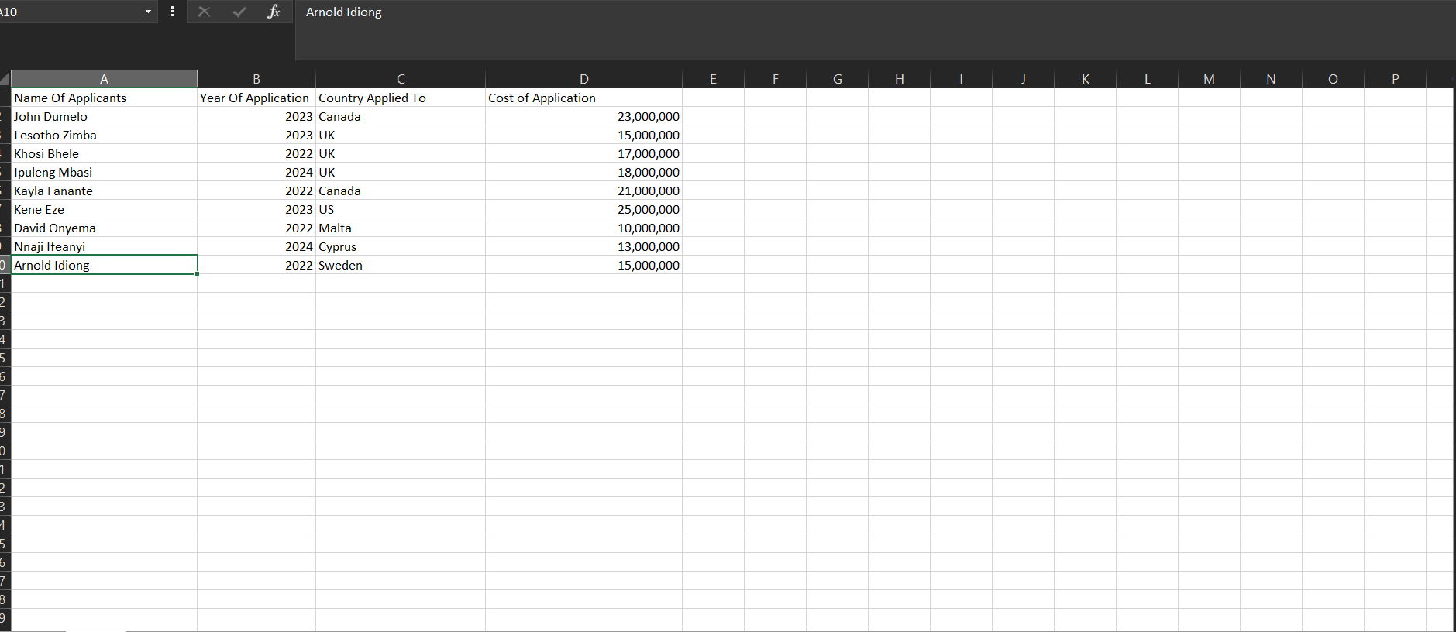

After this was done, I imported the sample on to Microsoft Power BI where I transformed the data to be accurate for the report
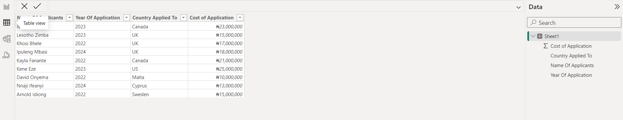

I started out by using the matrix visual to show the cost of living for each student in details and reference to their various countries and the total cost of living all together. Then I used a pie chart to show the sum of costs of application by country applied to. The Clustered Line column I created was to represent the number of applicants that applied in a particular year in respect to the various countries, I also created slicers so as to filter the pie charts and the clustered line column.
P.S: Slicers are visualizations used to filter certain details information in a report.
